UseCase Diagram:



Sequence Diagram:



Collaboration Diagram:



StateChart Diagram:



Activity Diagram:





**DEPLOYMENT DIAGRAM:**

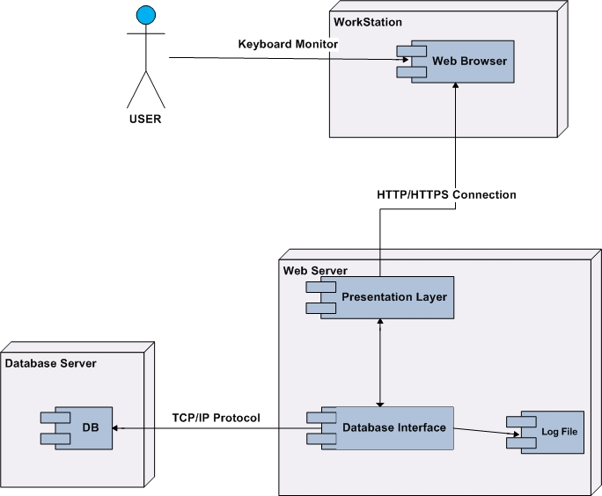

**COMPONENT DIAGRAM:**

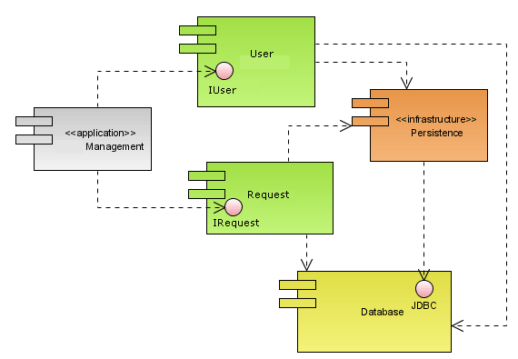

**CONTEXT LEVEL 0 DIAGRAM:**

**CONTEXT LEVEL DATAFLOW DIAGRAM**

**DATABASE**

**Data O/p stage**

**Switch**

**UI Screens**

**Data i/p stage Data O/p stage**

**Reports**

**Data o/p stage**

**A New Architecture for Network Intrusion Detection and Prevention**

a

**System Process**

**Context level1 Diagram:**

**Login DFD**

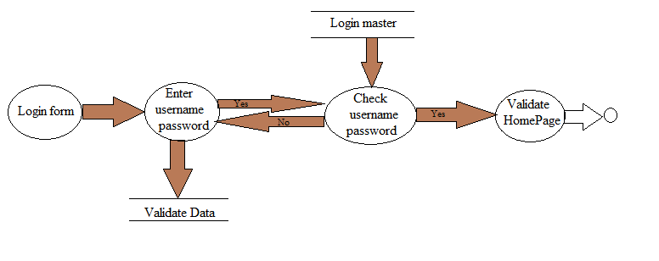

**Context level 2:**

**Switch**

**UI Displays set of operations**